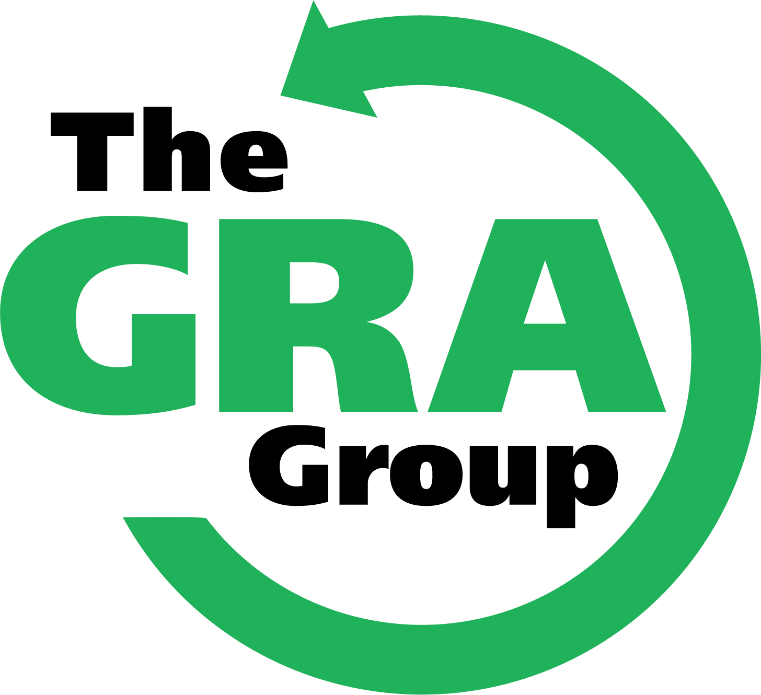

Trip Client
Planning Manual
2021 Programs

